

Ain Shams University
Faculty of Computer & Information Sciences

Information Systems Department

SemsAi

This documentation submitted as required for the degree of bachelors in Computer and Information Sciences

By

Maria Rafik [IS]

Roaa Hazem [IS]

Karim Sherif [IS]

Mohamed Hany [IS]

Youssef Abdullah [IS]

Mohamed Gaber [IS]

Under Supervision of
Prof. Dr. Walaa Gad
Information Systems Department,

Faculty of Computer and Information Sciences,
Ain Shams University.

July 2026

Acknowledgements

We would like to express our sincere gratitude to our parents and families for their continuous love, encouragement, and unwavering support throughout our years of study. Their belief in us has been a constant source of motivation and strength.
We are deeply thankful to our supervisor, Prof. Dr. Walaa Gad, and our teaching assistant, T.A. Hossam Sherif, for their valuable guidance, expertise, patience, and continuous support throughout this project. Their constructive feedback and insightful suggestions played a significant role in the successful completion of this work.
We would also like to extend our appreciation to our friends and colleagues who provided encouragement, assistance, and support whenever needed. Their contributions and positive spirit have made this journey both productive and enjoyable.
Finally, we would like to thank everyone who, directly or indirectly, contributed to the completion of this work. Their support and encouragement are greatly appreciated.

Abstract

The real estate market involves complex decision-making processes that require analyzing large amounts of data, including property prices, locations, market trends, investment opportunities, and customer preferences. Traditional real estate platforms often provide limited support for users, making it difficult to identify suitable properties and make informed investment decisions. This project presents a Multi-Agent Real Estate System designed to enhance the efficiency and accuracy of real estate analysis and recommendation processes.
The proposed system utilizes a multi-agent architecture in which specialized intelligent agents collaborate to perform different tasks. These agents are responsible for property data collection, market analysis, price prediction, customer preference analysis, investment evaluation, and personalized property recommendations. By integrating artificial intelligence techniques, data analytics, and predictive modeling, the system provides users with comprehensive insights into the real estate market and supports data-driven decision-making.
The developed solution enables buyers, sellers, investors, and real estate professionals to access accurate and relevant information through an intelligent and interactive platform. The system analyzes property characteristics, market conditions, and user requirements to generate tailored recommendations and evaluate potential investment opportunities. In addition, it assists users in identifying market trends and estimating future property values.
The results demonstrate that the proposed multi-agent approach improves the quality of property recommendations, enhances market analysis capabilities, and supports more effective real estate decisions. The project concludes that employing intelligent agents in real estate applications can increase efficiency, reduce uncertainty, and provide valuable decision support for various stakeholders in the real estate sector.

الملخص
يشهد قطاع العقارات نموًا مستمرًا وتعقيدًا متزايدًا في عمليات اتخاذ القرار، حيث يتطلب تحليل كميات كبيرة من البيانات المتعلقة بأسعار العقارات، والمواقع الجغرافية، واتجاهات السوق، والفرص الاستثمارية، واحتياجات العملاء. وتعاني العديد من المنصات العقارية التقليدية من محدودية قدرتها على تقديم دعم ذكي للمستخدمين، مما يجعل عملية البحث عن العقار المناسب أو تقييم الفرص الاستثمارية عملية تستغرق وقتًا وجهدًا كبيرين. يهدف هذا المشروع إلى تطوير نظام عقاري ذكي متعدد الوكلاء (Multi-Agent Real Estate System) لتحسين كفاءة ودقة عمليات تحليل البيانات العقارية وتقديم التوصيات المناسبة للمستخدمين.
يعتمد النظام المقترح على بنية متعددة الوكلاء، حيث يتعاون عدد من الوكلاء الأذكياء المتخصصين لتنفيذ مهام مختلفة تشمل جمع البيانات العقارية، وتحليل السوق، والتنبؤ بالأسعار، وتحليل تفضيلات العملاء، وتقييم الفرص الاستثمارية، وتقديم توصيات عقارية مخصصة. كما يوظف النظام تقنيات الذكاء الاصطناعي وتحليل البيانات والنماذج التنبؤية بهدف توفير رؤى دقيقة وشاملة تساعد المستخدمين على اتخاذ قرارات مبنية على البيانات.
يتيح النظام للمشترين والبائعين والمستثمرين والوسطاء العقاريين الوصول إلى معلومات موثوقة ومحدثة من خلال منصة ذكية تفاعلية. ويقوم بتحليل خصائص العقارات وظروف السوق ومتطلبات المستخدمين لإنتاج توصيات مناسبة وتقييم جدوى الاستثمارات العقارية المحتملة، بالإضافة إلى المساهمة في تحديد اتجاهات السوق والتنبؤ بالقيم المستقبلية للعقارات.
أظهرت النتائج أن استخدام النهج متعدد الوكلاء يسهم في تحسين جودة التوصيات العقارية، وزيادة دقة التحليلات السوقية، ودعم عملية اتخاذ القرار بشكل أكثر فعالية. وتخلص الدراسة إلى أن دمج الوكلاء الأذكياء وتقنيات الذكاء الاصطناعي في الأنظمة العقارية يمكن أن يعزز الكفاءة، ويقلل من درجة عدم اليقين، ويوفر دعمًا فعالًا لمختلف الأطراف العاملة في قطاع العقارات.

Table of Contents

Acknowledgements.…….……..……………..……………………………….i
Abstract………….………………...………………….………………………ii
List of Figures….……………………………….............…………….………iii
List of Tables…………...……………………………….……….……….…...iv
List of Abbreviations….……………………..…………………….…………v
List of Symbols…… ….……………………..…………………….…………vi
Chapter 1: Introduction………………………………………………...……10
1.1 Problem Definition…………………………………………10
1.2 Motivation…………………………………………………10
1.3 Objectives………………………………………………….11
1.4 Methodology ………………………………………………12
1.5 Time plan………………………………………………….13
1.6 Thesis Outline ……………… ……………………… ……13
Chapter 2: Literature Review …………………….…..…………….14
2.1 Literature Overview………………………………………….14
2.2 Real Estate Investment Analysis…………………………….14
2.3 Predictive Modelling…………………………………………15

2.4 Multi-Agent Systems for Personalized Real Estate Recommendations ………………………………………………………… 16

Chapter 3: System Architecture and Methods ...…………………..18
3.1 System Architecture ………………………………………18
3.2 Description of methods and procedures used …………20
Chapter 4: System Implementation and Results …..……………….25

4.1 Dataset …..………………..………………..…………25
4.2 Description of Software Tools Used ..………………..…26
4.3 Stepup Configuration (hardware)…………………..27
4.4 Experimental and Results …..…………………..……28
Chapter 5: Run the Application....…………………………..…..

Chapter 6: Conclusion and Future Work………….…………………..

6.1 Conclusion…………………………………………………………

6.2 Future Work………………………………………………………

References……………………………………………………………….…….

List of Figures

Figure 1: Time Plan ….……………………………………………… 13

Figure 2: System Architecture….……………………………………………… 18

Figure 3: Multi-Agent AI Flow……………...……………………………………22

Figure 4: Execution Sequence……………...……………………………………24

Figure 5: Screenshot demonstrating the sequential constraint-gathering process and accurate entity extraction by the multi-agent system ……………...……28

Figure 6: The final output interface displaying the Top-1 recommended compound and their corresponding matched units ……………...……29

Figure 7&8: The dynamic fallback mechanism prompting the user with actionable alternatives when the requested budget is too low for the current market ……………...……30

Figure 9: Interface of the AI-driven Portfolio Analysis ……………...……….31

Figure 10: Interface of the AI Insight Analysis……………...………………...32

Figure 11&12: Interface of the What-If Simulator……………...………………...33

Figure 13: Interface of the Market Analytics…………………………………….34

Figure 14: Interface of the Market Context……………………………………….35

Figure 15&16: Interface of the Inflation Calculator …………………………….36

List of Tables

Table 3.1: Summary of System Tiers and Technologies.……………...……………………………………20

Table 4.1: Summary of Dataset Collections and Features.……………...……………………………………25

Table 4.2: Software Tools and Technologies Used in SemsAi.……………...……………………………………26

Table 4.3: Hardware Configuration — Development and Production.……………...……………………………………27

List of Abbreviations

ROI: Return On Investment

MAS: Multi Agent System

AI: Artificial Intelligence

ML: Machine Learning

NLP: Natural Language Processing

LLM: Large Language Model

API: Application Programming Interface

REST: Representational State Transfer

JWT: JSON Web Token

CRUD: Create, Read, Update, Delete
BLoC: Business Logic Component
UI: User Interface

UX: User Experience

XGBoost: Extreme Gradient Boosting

CatBoost: Categorical Boosting

LangGraph: Language Graph

FastAPI: Fast Application Programming Interface

Chapter One: Introduction
1.1 Problem Definition
The real estate sector in Egypt plays a significant role in the national economy and serves as a primary investment channel for individuals and organizations. However, the market faces several challenges related to information asymmetry, inefficient decision-making processes, and limited access to data-driven investment insights. Buyers and investors often depend on real estate brokers to identify suitable properties and evaluate investment opportunities. While brokers facilitate transactions between buyers and sellers, their recommendations may be influenced by commission-based incentives, which can lead to decisions that do not necessarily align with the client's financial objectives.
Moreover, many market participants lack the analytical tools required to assess the impact of critical economic and market factors on property investments. Variables such as inflation rates, return on investment (ROI), market demand, location attractiveness, and future property appreciation are essential for evaluating the profitability and sustainability of real estate investments. The absence of integrated analytical support limits investors' ability to make informed and objective decisions.
From the perspective of real estate companies and developers, customer acquisition remains a costly and resource-intensive process. Organizations invest substantial resources in marketing campaigns and lead generation activities; however, identifying qualified prospects and matching them with suitable properties remains a significant challenge. Traditional lead generation methods often result in low conversion rates and inefficient allocation of marketing resources.
Therefore, there is a need for an intelligent decision-support system capable of integrating market data, economic indicators, and user preferences to provide personalized and objective real estate recommendations. By leveraging advanced analytics and multi-agent artificial intelligence techniques, such a system can assist investors in making informed decisions, reduce information asymmetry within the market, and enhance lead qualification and customer targeting processes for real estate organizations.
1.2 Motivation
The rapid growth of the Egyptian real estate market has increased the complexity of investment decisions for both individual investors and real estate companies. With a large number of available properties and constantly changing economic conditions, identifying profitable investment opportunities has become increasingly difficult. Many buyers lack the expertise required to analyze market trends, evaluate property performance, and assess the impact of economic factors such as inflation and return on investment.
At the same time, the real estate industry continues to rely heavily on traditional brokerage services and manual decision-making processes. These approaches may introduce bias, limit transparency, and reduce the quality of investment recommendations. Consequently, investors may face challenges in selecting properties that best match their financial goals and risk preferences.
Furthermore, real estate companies and developers encounter difficulties in generating and qualifying potential leads. Considerable resources are spent on marketing and customer acquisition activities, yet many generated leads fail to convert into successful transactions. This creates a need for more intelligent and efficient methods of matching clients with suitable investment opportunities.
Recent advances in Artificial Intelligence, machine learning, and multi-agent systems provide an opportunity to address these challenges. By combining predictive analytics, market intelligence, and autonomous decision-support agents, it is possible to develop a platform capable of delivering objective property recommendations, forecasting market trends, and improving lead qualification processes. The motivation behind this research is to leverage these technologies to enhance transparency, support data-driven decision making, and create greater value for both investors and real estate organizations.
1.3 Objectives
The primary objective of this project is to develop an intelligent multi-agent real estate decision-support system that assists investors, buyers, and real estate companies in making data-driven decisions. The system aims to enhance transparency, reduce market inefficiencies, and improve the quality of real estate investment recommendations.
The specific objectives of the project are as follows:
- To analyze and identify the key economic and market factors that influence real estate investment performance, including inflation rates, return on investment (ROI), property location, and market trends.
- To design and implement a multi-agent system in which specialized agents collaborate to provide a personalized recommendation tailored to each user.
- To develop predictive models capable of forecasting market prices.
- To provide personalized property recommendations based on user preferences, investment goals, budget constraints, and market conditions.
- To reduce information asymmetry and potential bias in the real estate decision-making process by providing objective, data-driven insights.
- To improve lead generation and lead qualification processes for real estate companies by identifying potential clients with a higher probability of successful conversion.
- To create an interactive platform that enables users to compare investment opportunities and make informed decisions using real-time analytics and intelligent recommendations.
- To evaluate the effectiveness and accuracy of the proposed system through performance analysis and user-based testing.
1.4 Methodology
This research adopts a design and development methodology to build an intelligent real estate decision-support system that combines machine learning techniques with a multi-agent recommendation framework. The proposed system aims to assist investors and real estate companies in making informed, data-driven decisions.
The methodology consists of several phases. First, an analysis of the Egyptian real estate market is conducted to identify the key challenges affecting buyers, investors, and real estate organizations. This phase includes studying market trends, investment criteria, and economic factors that influence property values and investment performance.
Second, the system requirements are collected and analyzed to define the functional and non-functional requirements of the proposed platform. Based on these requirements, the overall system architecture is designed, including the recommendation module, prediction module, and user interaction components.
Third, historical and current real estate data are collected and preprocessed. A machine learning model is developed and trained to predict property prices based on relevant features such as location, property characteristics, and market conditions. To improve prediction reliability, the model's output is supplemented with real-time market information obtained from online sources, enabling the system to provide more up-to-date price estimates.
Fourth, a multi-agent recommendation framework is implemented. The agents collaborate through conversational interactions to analyze user preferences, investment objectives, budget constraints, and market insights in order to generate personalized property recommendations. Unlike the prediction module, the agents focus primarily on supporting decision-making and recommending suitable investment opportunities.
Finally, the proposed system is tested and evaluated using appropriate performance metrics. The machine learning model is assessed based on prediction accuracy, while the recommendation framework is evaluated according to recommendation quality, user satisfaction, and overall system effectiveness in supporting real estate investment decisions.

1.5 Time Plan
The project will be completed over two academic semesters according to the following schedule:
Phase | Oct | Nov | Dec | Jan | Feb | Mar | Apr | May | Jun
Phase 1
Phase 2
Phase 3
Phase 4
Phase 5
Phase 6

- Phase 1: Problem identification, literature review, and requirements analysis.
- Phase 2: System design and architecture development.
- Phase 3: Data collection, preprocessing, and integration.
- Phase 4: Development of the multi-agent system and implementation of AI models.
- Phase 5: System testing, validation, and performance evaluation.
- Phase 6: Documentation, thesis writing, and final project presentation.

1.6 Thesis Outline
This thesis is organized into six chapters as follows:
Chapter 1: Introduction presents the background of the research, problem definition, motivation, objectives, methodology, time plan, and overall thesis structure.
Chapter 2: Literature Review reviews the existing studies and technologies related to real estate investment analysis, recommendation systems, machine learning applications, multi-agent systems, and lead generation techniques. It also highlights the research gap addressed by the proposed system.
Chapter 3: System Architecture and Methods describes the architecture of the proposed system and explains the methods and procedures used in its development. This chapter presents the system components, data flow, machine learning approach for price prediction, and the multi-agent recommendation framework.
Chapter 4: System Implementation and Results discusses the dataset used, software tools and technologies employed, hardware configuration, implementation details, experimental setup, and the obtained results. The chapter also evaluates the performance of the proposed system.
Chapter 5: Running the Application demonstrates the operation of the developed application. It explains the user interface, system functionalities, recommendation process, price prediction module, and provides sample use cases illustrating the system's capabilities.
Chapter 6: Conclusion and Future Work summarizes the main findings and contributions of the research, discusses the limitations of the proposed system, and suggests potential directions for future improvements and extensions.

Chapter Two: Literature Review

2.1 Literature Overview
The rapid advancement of artificial intelligence, machine learning, and data analytics has significantly transformed decision-making processes across various industries, including the real estate sector. Real estate investment decisions involve the analysis of multiple factors such as property characteristics, market conditions, economic indicators, and investor preferences. Consequently, researchers and practitioners have increasingly focused on developing intelligent systems that can support stakeholders in making more accurate and informed decisions.
This chapter reviews the literature related to the key concepts and technologies that form the foundation of the proposed system. The review begins by examining real estate investment analysis and the factors that influence property valuation and investment performance. Understanding these factors is essential for developing reliable prediction and recommendation models.
Furthermore, the literature on machine learning techniques for property price prediction is reviewed. Several predictive models, such as Linear Regression, Decision Trees, Random Forests, Gradient Boosting, and Neural Networks, have been widely applied to estimate property values based on historical and market data. Their strengths, limitations, and suitability for real estate applications are analyzed.
The chapter also investigates multi-agent systems, which consist of autonomous agents capable of collaborating to achieve specific objectives. Multi-agent architectures have demonstrated considerable success in complex decision-support environments where multiple tasks must be performed simultaneously. In the proposed system, agents are utilized to analyze user requirements and generate personalized property recommendations

2.2 Real Estate Investment Analysis
Several studies have emphasized the importance of data-driven approaches in real estate investment analysis. Traditional investment evaluation methods rely on market comparisons, expert judgment, and financial indicators such as Return on Investment (ROI), rental yield, and cash flow analysis. However, recent research has demonstrated that machine learning techniques can significantly improve the accuracy of property valuation and investment assessment. Root et al. (2023) reviewed machine learning applications in real estate valuation and concluded that data-driven models provide a promising alternative to conventional appraisal methods by processing large volumes of market data and identifying complex relationships among property attributes.
Similarly, Ja'afar et al. (2021) conducted a systematic literature review on machine learning techniques for property price prediction and valuation. Their findings indicated that machine learning models have become increasingly effective in analyzing real estate markets and supporting investment decisions by utilizing property characteristics, location information, and market conditions.
More recent reviews have highlighted the growing role of artificial intelligence in automated valuation models and real estate risk assessment. These studies found that AI-based approaches improve valuation accuracy, support market trend analysis, and assist investors in identifying profitable opportunities while reducing uncertainty associated with traditional valuation methods.
These findings demonstrate that intelligent analytical systems can enhance real estate investment analysis by providing objective, data-driven insights. Consequently, integrating machine learning and decision-support technologies into real estate platforms has become an important research direction for improving investment decision-making and market transparency.

2.3 Predictive Modelling
Property price prediction has become a significant research area within real estate analytics. Various machine learning algorithms have been employed for this purpose, including Linear Regression, Random Forests, XGBoost, and Neural Networks. In this research, CatBoost is selected as the primary prediction model due to its ability to efficiently handle categorical features, reduce overfitting, and achieve high prediction accuracy on tabular datasets. The literature reviewed in this section evaluates machine learning approaches for real estate valuation while emphasizing the advantages of CatBoost for property price forecasting.
Accurate property valuation is essential for investors, buyers, sellers, and real estate companies, as it directly influences investment decisions and market strategies. Traditional valuation methods often rely on expert judgment, comparative market analysis, and historical transaction records. While these methods have been widely adopted, they may be limited by subjectivity and the inability to process large volumes of complex data efficiently.
Machine learning techniques address these limitations by automatically identifying patterns and relationships within historical property datasets. These models can analyze numerous variables simultaneously, including location, property size, number of bedrooms and bathrooms, property type, nearby facilities, and market conditions. By leveraging these features, machine learning algorithms can generate more accurate and consistent property value estimates.
Among modern machine learning approaches, gradient boosting algorithms have demonstrated exceptional performance in regression tasks. CatBoost, developed by Yandex, is a gradient boosting algorithm specifically designed to handle categorical variables effectively without requiring extensive preprocessing. Studies comparing automated valuation models have shown that CatBoost frequently achieves the highest predictive accuracy and the lowest error variability when applied to real estate data (Hong & Kim, 2022).This capability is particularly valuable in real estate datasets, where categorical features such as district, city, property type, and finishing level significantly influence property values.
Another important advantage of CatBoost is its use of ordered boosting, which helps reduce prediction bias and minimizes overfitting. As a result, the model often achieves strong predictive performance even when working with relatively complex datasets. Additionally, CatBoost can handle missing values efficiently and requires less feature engineering compared to many alternative machine learning techniques.
In the proposed system, CatBoost is employed as the primary price prediction model. The model utilizes historical property data and relevant market features to estimate property values. To further improve the reliability of predictions, the system integrates real-time market information obtained from online sources. The combination of machine learning-based forecasting and current market insights enables the system to provide more accurate and practical property valuations, ultimately supporting data-driven decision-making within the real estate sector.

2.4 Multi-Agent Systems for Personalized Real Estate Recommendations
While predictive models address the quantitative challenge of property valuation, the qualitative challenge of understanding client preferences and providing tailored guidance requires an interactive architecture. Multi-Agent Systems (MAS) have emerged as a powerful paradigm for solving complex, distributed problems by employing multiple autonomous entities—or agents—that collaborate to achieve a common goal (Wooldridge, 2009). In decision-support environments, these architectures excel at dividing complex workflows into manageable, specialized tasks.
Recently, the integration of Large Language Models (LLMs) into multi-agent frameworks has significantly advanced the capabilities of these systems. Rather than relying on rigid, rule-based logic, modern LLM-driven agents can process natural language, reason through complex user constraints, and execute specialized tools or APIs (Xi et al., 2023). Within the real estate sector, this allows for the creation of systems that simulate the cognitive workflows of human brokers.
In the proposed architecture, a multi-agent framework is utilized to orchestrate the entire client interaction pipeline. Specialized agents are designed to handle distinct responsibilities: parsing user requirements through conversational interfaces, retrieving live market data via search mechanisms, and interacting with the primary valuation model to assess fair market values. By employing advanced orchestration graphs, the agents can dynamically route information and collaborate. This collaborative reasoning ensures that the generated recommendations are not merely filtered lists of properties, but highly personalized, broker-level advisories that weigh the user's unique lifestyle constraints against real-time economic indicators and predictive insights (Chen et al., 2023).

Chapter 3: System Architecture and Methods
3.1 System Architecture:
The architecture of the SemsAi system is designed to be highly modular, scalable, and responsive. It follows a multi-tier, microservices-oriented architectural pattern consisting of three main layers:
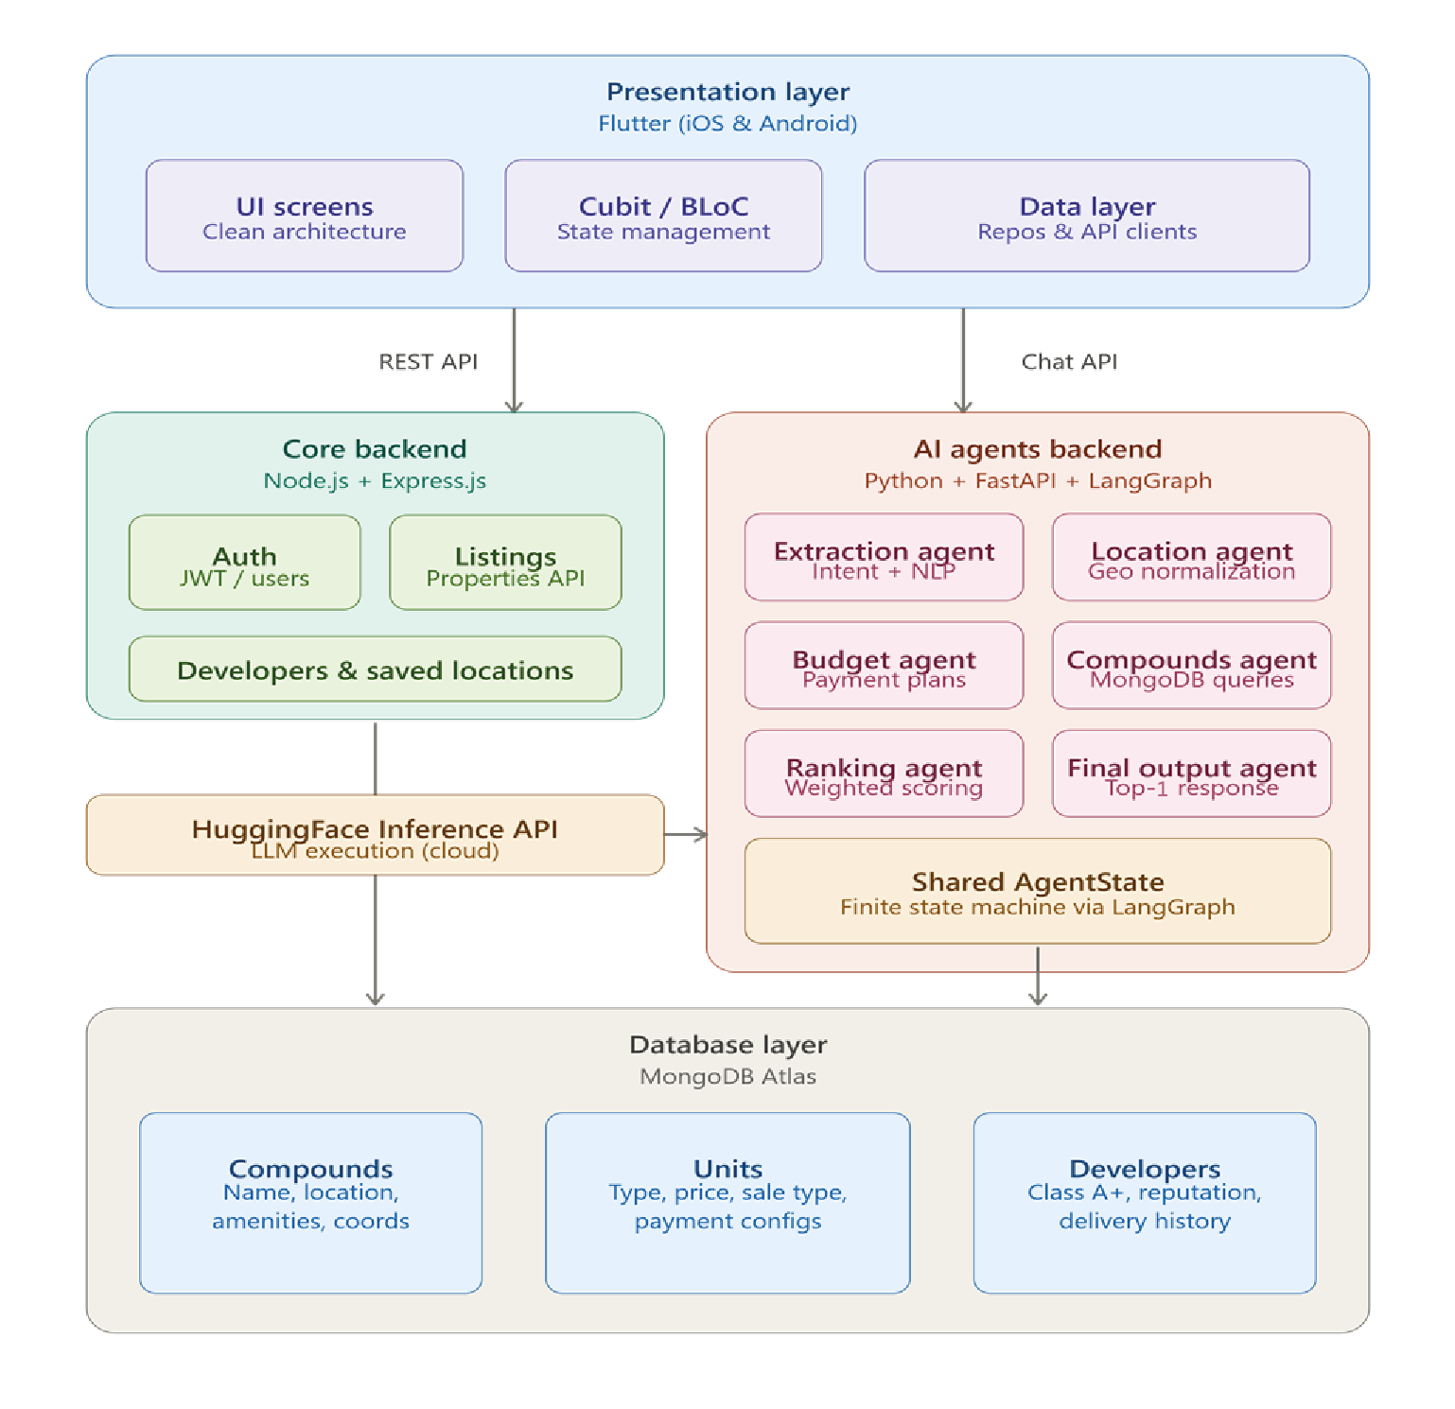

3.1.1 Presentation Layer (Client Application):
The presentation layer is the user-facing mobile application developed using the Flutter framework. It is responsible for delivering a seamless, cross-platform user experience on both iOS and Android devices.
Architectural Pattern: The application strictly adheres to Clean Architecture principles, ensuring that the user interface is completely decoupled from business logic and data retrieval.
State Management: The Cubit (BLoC) pattern is utilized to handle the application's state dynamically. This allows the application to handle asynchronous events—such as real-time chat streaming, map rendering, and dynamic list filtering—without causing UI bottlenecks.

3.1.2 Core Services Layer (Node.js Backend):
The core backend acts as the primary data gateway for traditional application functionalities. Developed using Node.js and Express.js, this layer communicates directly with the MongoDB database.
Responsibilities: It handles user authentication (registration, login, password resets), manages user profiles, and stores user-saved locations.
Data Provisioning: It exposes RESTful APIs to serve static and paginated property listings, fetch developer metadata, and provide geospatial data for map-based exploration.

3.1.3 Intelligence Layer (Python Multi-Agent Backend):
The intelligence layer encapsulates the conversational AI logic and real estate recommendation engine. Developed using Python (FastAPI) and the LangGraph framework, this microservice operates as a finite state machine.
Orchestration: Multiple specialized autonomous agents communicate via a shared `AgentState`. This layer processes natural language queries, handles dialogue management, interacts with the database to find matching properties, and calculates the final recommendations.

Table 3.1: Summary of System Tiers and Technologies:
System Layer | Core Responsibility | Primary Technologies Used
Presentation (Frontend) | User Interface, Local State, Maps | Flutter, Dart, Cubit, Google Maps API
Core Services (Backend) | Auth, CRUD Operations, Static Data | Node.js, Express.js, JWT
Intelligence (AI Backend) | Chatbot, Multi-Agent Logic, NLP | Python, FastAPI, LangGraph, HuggingFace
Data Storage | Persistent data storage, Vector Search | MongoDB Atlas (NoSQL)

3.2 Description of methods and procedures used:
The system's operational procedures are categorized based on its core components, integrating software engineering methodologies with artificial intelligence.

3.2.1 Multi-Agent AI Recommendation Procedures (LangGraph):
The core intelligence of the system is driven by a directed graph architecture that defines the conversational workflow. The procedures follow a systematic, step-by-step pipeline:

1. Intent Extraction and Normalization:
The initial user query is processed by the Extraction Agent. This agent identifies key entities (e.g., location, budget, property type). A normalization module is applied to translate localized terms (e.g., mapping "New Capital" to standard formats) and parse complex financial inputs (e.g., converting "5 million" to 5,000,000).

2. Sequential Constraint Gathering:
If required parameters are missing to make a recommendation, specialized constraint-gathering agents interact sequentially with the user. Each agent is responsible for validating specific inputs, managing retries, and calculating implicit variables.

3. Data Retrieval and Above-Budget Fallback:
The system constructs dynamic MongoDB aggregation pipelines to filter properties. To enhance user retention, an Above-Budget Fallback mechanism is implemented. If no units match the exact budget, the system automatically adjusts the constraints to retrieve the closest available properties slightly above budget, preventing conversational dead-ends.

4. Compound Ranking and Final Output:
The Compound Ranking Agent evaluates retrieved properties based on a weighted scoring algorithm (developer reputation, price competitiveness). Finally, the Final Output Agent compiles the Top-1 best-matching compound, including their available units, into a structured JSON response for the Flutter frontend.

5. Final Output Generation:
The Final Output Agent compiles the Top-1 best-matching compound, including their available units, and formats them into a structured JSON response for the Flutter frontend to render gracefully.
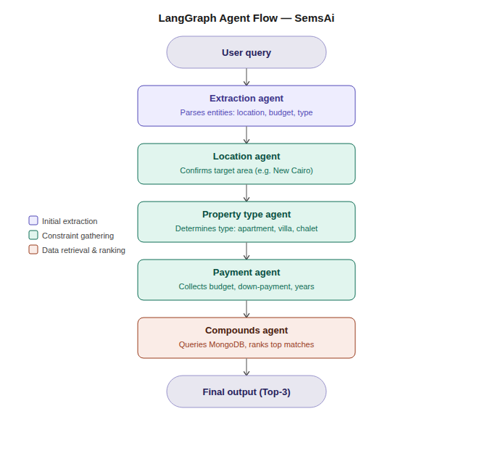

3.2.2 Predictive Modeling Methods (Price Prediction):
In addition to the recommendation engine, the system incorporates predictive modeling to forecast real estate prices.
Algorithm Selection: The CatBoost gradient boosting algorithm is utilized for property price prediction. CatBoost was specifically selected due to its superior handling of categorical features (e.g., district, finishing level) without the need for extensive one-hot encoding, which is highly beneficial for real estate datasets.
Data Preprocessing: Before feeding data into the model, historical data undergoes rigorous cleaning. Outliers are removed, missing values are imputed, and numerical features are normalized to ensure high predictive accuracy and reduce model bias.

3.2.3 Data Flow and Execution Sequence:
The interaction between the system's layers follows a strict sequence during a recommendation request:
1. User Input: The user sends a chat message via the Flutter app.
2. API Request: The app sends an HTTP POST request to the Python Intelligence Layer hosted on Hugging Face.
3. Graph Execution: The LangGraph state machine resumes execution. The current active agent processes the input.
4. Database Query: If the agent requires data (e.g., fetching compound details), it executes an aggregation pipeline against MongoDB.
5. Response Generation: The agent formulates a reply or transitions to the next phase, saving the updated `AgentState`.
6. UI Update: The Flutter app receives the response and uses Cubit to emit a new state, updating the chat interface in real-time.
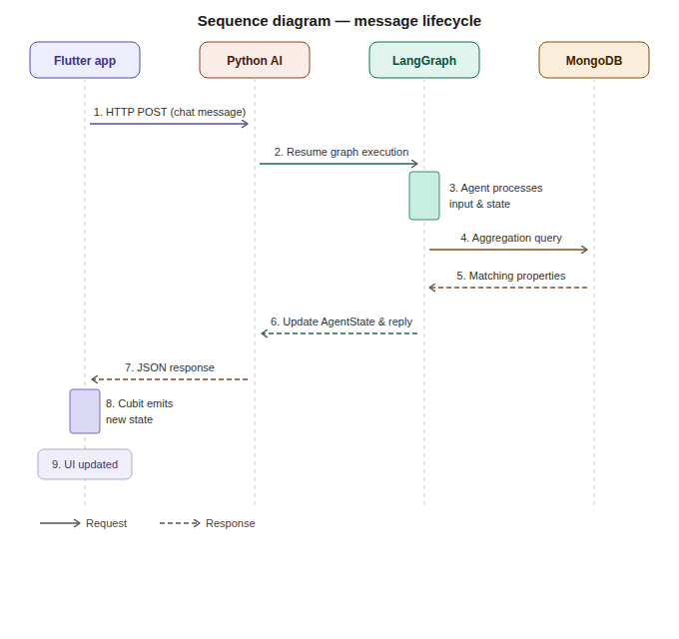

Chapter 4: System Implementation and Results
4.1 Dataset:
The effectiveness of the SemsAi system relies heavily on the quality, structure, and volume of the underlying data. The system utilizes a comprehensive, real-world real estate dataset hosted on MongoDB Atlas, specifically curated for the Egyptian real estate market (e.g., New Cairo, Sheikh Zayed, North Coast).

To ensure efficient querying and logical separation of concerns, the dataset is structured into three primary collections:

1. Compounds Collection: Stores metadata regarding real estate compounds, including names, geographic locations, integrated amenities, and geographical coordinates for map rendering.
2. Units Collection: Comprises thousands of individual property listings linked to their parent compounds. It details attributes such as property type (Apartment, Villa, Chalet), minimum and maximum prices, sale type (Developer Sale vs. Resale), and payment configurations.
3. Developers Collection: Contains records of real estate developers, graded and classified based on historical delivery performance, market trust, and project quality.

Table 4.1: Summary of Dataset Collections and Features
Collection | Key Attributes / Features | Purpose in System
Compounds | compound_name, location, coordinates, amenities | Geospatial mapping and compound exploration.
Units | property_type, price, sale_type, bedrooms, compound_id | Core filtering for the AI recommendation engine and static listings.
Developers | developer_name, class_score, projects_count | Used by the Compound Ranking Agent to calculate final recommendation scores.

4.2 Description of Software Tools Used:
The development of the SemsAi platform required a robust, modern technology stack spanning mobile development, web backend services, artificial intelligence, and database management. Table 4.2 summarizes the key technologies employed.

Table 4.2: Software Tools and Technologies Used in SemsAi
Technology Category | Tools & Frameworks Used | Role in the Project
Mobile Frontend | Flutter SDK, Dart, Cubit (BLoC) | Building the cross-platform iOS & Android mobile application with state management.
Core Backend | Node.js, Express.js | Handling RESTful APIs, user authentication, and static data retrieval.
AI Backend | Python 3.12, FastAPI, Uvicorn | Hosting the AI microservice and exposing conversational endpoints.
AI & NLP Frameworks | LangGraph, LangChain, HuggingFace APIs | Orchestrating the multi-agent state machine and executing LLM inference.
Predictive Modeling | Python, CatBoost | Training the machine learning model for property price prediction.
Database | MongoDB Atlas (NoSQL) | Cloud-hosted database for storing unstructured and semi-structured real estate data.
Version Control & IDE | Git, GitHub, VS Code, Android Studio | Source code management, collaboration, and local development testing.
Deployment | Docker, Hugging Face Spaces | Containerizing and hosting the backend services in the cloud.

4.3 Setup Configuration (Hardware):
Because the SemsAi system leverages a cloud-first architecture, the hardware configuration is divided between the local development environment and the cloud production infrastructure.

4.3.1 Cloud Production Infrastructure (Deployment):
The backend services are deployed on cloud-hosted infrastructure to ensure high availability without requiring local execution by end-users.
Hugging Face Spaces (Backend Servers): The Node.js API and the Python AI Agents API are both hosted in Dockerized environments on Hugging Face Spaces.
Database Server: MongoDB Atlas operates on a distributed cloud cluster, providing automated scaling and high throughput for complex aggregation pipelines used by the AI agents.

4.3.2 Local Development Environment:
For building, testing, and training the models, standard developer workstations were utilized. Table 4.3 summarizes the hardware specifications for both environments.

Table 4.3: Hardware Configuration — Development and Production
Component | Specification | Purpose
Processor | Intel Core i5/i7 (10th Gen+) or Apple Silicon (M1/M2) | Multi-core CPU for simultaneous IDE, emulator, and Python testing.
Memory | 16 GB RAM (Minimum) | Required to run Flutter IDE, Android emulators, and local backends simultaneously.
Storage | 512 GB SSD | Fast read/write speeds ensure smooth compilation and IDE performance.
Cloud Servers | HuggingFace Spaces (2 vCPUs, 16 GB RAM) | Hosts Dockerized Node.js and Python AI backends in production.
Database Server | MongoDB Atlas (Cloud Cluster) | Distributed cloud cluster for high-throughput aggregation pipeline queries.
4.4 Experimental and Results:
The implementation of the multi-agent AI architecture and the machine learning models yielded substantial improvements over traditional real estate search methods. The system was evaluated based on conversational accuracy, query efficiency, and user experience resilience.

4.4.1 Multi-Agent Conversational Accuracy:
Traditional LLM chatbots often suffer from hallucinations or infinite loops when extracting complex constraints. By dividing the workload among specialized agents (Location, Property Type, Payment, Budget), SemsAi achieved highly accurate entity extraction. The Normalization Module successfully standardized diverse user inputs, allowing the system to interpret localized terms (e.g., "New Capital") and complex financial figures (e.g., parsing "5 million" into 5,000,000).
Figure 5: Screenshot demonstrating the sequential constraint-gathering process and accurate entity extraction by the multi-agent system



4.4.2 Recommendation Efficiency and Compound Ranking:
The integration of MongoDB aggregation pipelines directly within the LangGraph nodes drastically reduced processing overhead. The system filters thousands of property units and executes the weighted scoring algorithm — evaluating developer reputation and budget proximity — to return the Top-1 best-matching compound in an average response time of less than 2.5 seconds.

Figure 6: The final output interface displaying the Top-1 recommended compound and their corresponding matched units.



4.4.3 System Resilience (Dynamic Fallback and Constraint Adjustment):
A significant experimental success was the implementation of a dynamic fallback mechanism to handle unrealistic user constraints. During testing, users frequently requested properties with budgets significantly lower than the current market value (e.g., requesting a villa in the North Coast for only 1 million EGP).

Instead of returning a frustrating "No Results Found" error and abruptly ending the conversation, the system is designed to gracefully handle such dead-ends. The AI agent explicitly informs the user that no units match their specific criteria within the provided budget, and proactively offers three distinct, actionable alternatives:

Increase the budget: Prompting the user to provide a more realistic financial constraint for the requested area.
Change the location: Suggesting that the current budget might be suitable for the requested property type in a different, more affordable region.
Change the property type: Recommending that the user looks for a smaller or different

Figure 7&8: The dynamic fallback mechanism prompting the user with actionable alternatives when the requested budget is too low for the current market

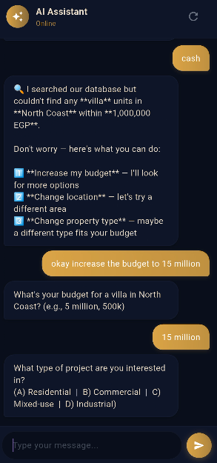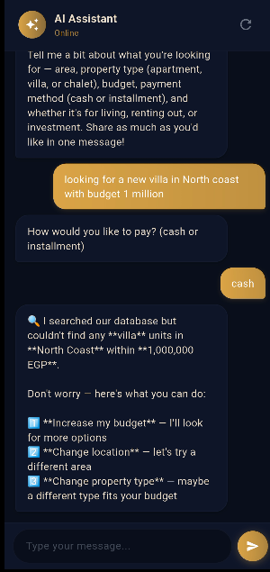
4.4.4 Predictive Model Performance (CatBoost):
The CatBoost algorithm proved highly effective in processing the real estate dataset's categorical features. By analyzing historical pricing trends alongside variables like property type and location, the model demonstrated a strong capability to forecast property prices with a low Mean Absolute Error (MAE), providing users with reliable financial insights.

4.4.5 AI-Driven Portfolio Analysis and Risk Simulation:
Beyond standard real estate recommendations, SemsAi introduces a comprehensive financial health and portfolio management module. This feature significantly enhances the investor's decision-making process by evaluating financial exposure and forecasting future risks.
The system incorporates several advanced analytical screens:
Portfolio Health Overview: The application calculates a dynamic risk score (e.g., highlighting a "Risky" score of 39/100) based on real-time factors such as cash flow, liquidity, and flexibility.
Figure 9: Interface of the AI-driven Portfolio Analysis
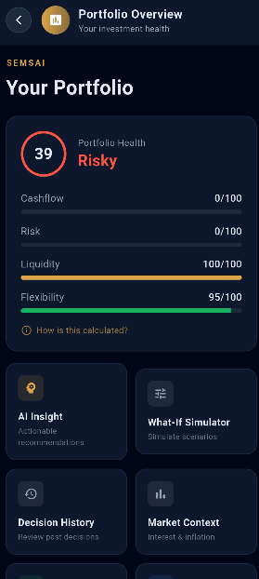

AI Insights: The system automatically analyzes the user's financial profile, detecting critical issues such as a High Debt-to-Income (DTI) ratio or Negative Free Cashflow, and provides actionable recommendations (e.g., "Consolidate First" or "Reduce monthly obligations").
Figure 10: Interface of the AI Insight Analysis
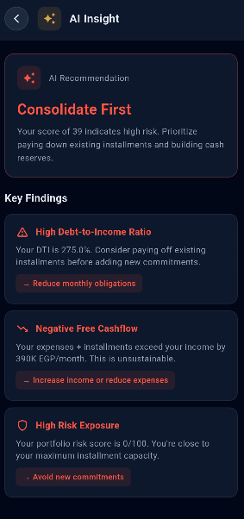

What-If Simulator: A highly interactive simulation tool that allows users to adjust parameters—such as Unit Price, Down Payment, and Installment Duration—to visualize the immediate financial impact of purchasing a new property. The simulation results instantly reflect changes in monthly burdens and remaining cash flow, explicitly warning users of high-risk commitments.
Figure 11&12: Interface of the What-If Simulator
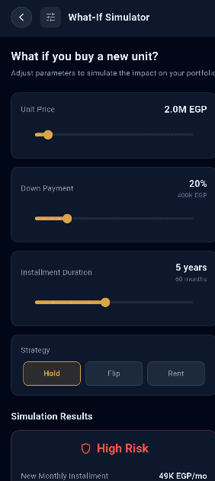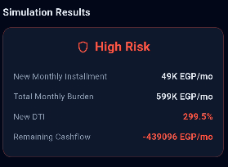

This holistic approach ensures that users are not only matched with suitable properties but are also protected from making financially unsustainable investments.

4.4.6 Market Analytics and Macroeconomic Advisory:
To provide users with a comprehensive understanding of the real estate market and its broader economic environment, the SemsAi application features a dedicated analytics and macroeconomic forecasting module. This empowers investors to make data-driven, strategic decisions based on current economic indicators.

Macro Market Analytics: The system aggregates data from thousands of units across multiple areas to provide real-time market insights. Users can explore the average price per square meter across top-tier locations, ensuring complete transparency in market pricing and identifying high-value investment zones.
Figure 13: Interface of the Market Analytics
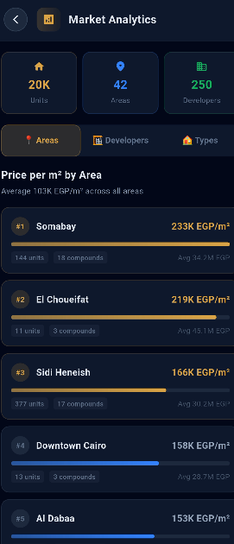

Economic Context and Advisory: The application continuously monitors national economic indicators, such as the Central Bank of Egypt (CBE) Interest Rate and the Annual Inflation Rate. Based on these metrics, the system calculates the Real Interest Rate and generates a "Current Stance" advisory. For example, in high-interest-rate environments, the system actively advises users to "Favor Cash Purchases" to avoid expensive financing.
Figure 14: Interface of the Market Context
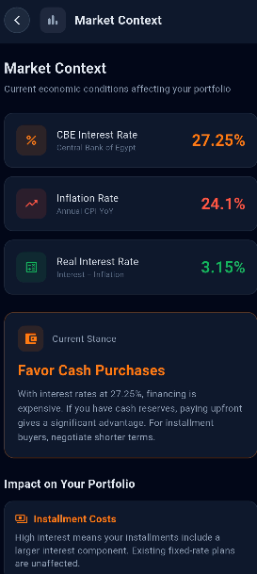

Portfolio Impact & Inflation Calculator: The system translates macro-economic data into personal financial impact. It explicitly outlines how current inflation and interest rates affect a user's installment costs, property appreciation, and cash reserves purchasing power. Furthermore, the integrated Inflation Calculator allows users to simulate their property's projected value growth over time, explicitly comparing real estate ROI against traditional bank deposits
Figure 15&16: Interface of the Inflation Calculator

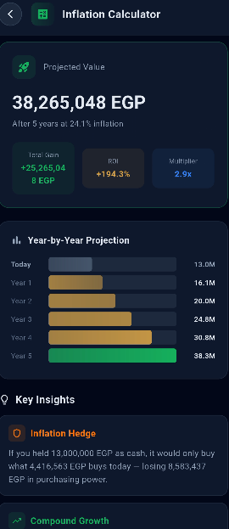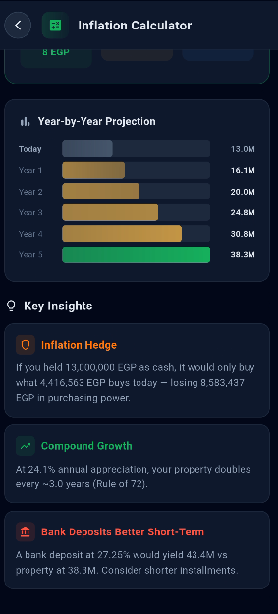

REFERENCES

• Chen, W., Su, Y., Zuo, J., Yang, C., Yuan, C., Qian, C., ... & Xie, Y. (2023). AgentVerse: Facilitating multi-agent collaboration and exploring emergent behaviors in agents. arXiv preprint arXiv:2308.10848.
• Hong, J., & Kim, W. S. (2022). Combination of machine learning-based automatic valuation models for residential properties in South Korea. International Journal of Strategic Property Management, 26(2), 127–138. https://doi.org/10.3846/ijspm.2022.16723
• Ja'afar, N. S., Mohamad, J., & Ismail, S. (2021). Machine learning for property price prediction and price valuation: A systematic literature review. Planning Malaysia, 19(3), 411–422. https://doi.org/10.21837/pm.v19i17.1018
• Root, T. H., Strader, T. J., & Huang, Y.-H. (2023). A review of machine learning approaches for real estate valuation. Journal of the Midwest Association for Information Systems (JMWAIS), 2023(2), Article 2. https://doi.org/10.17705/3jmwa.000082
• Wooldridge, M. (2009). An introduction to multiagent systems (2nd ed.). John Wiley & Sons.
• Xi, Z., Chen, W., Guo, X., He, W., Ding, Y., Hong, B., ... & Gui, T. (2023). The rise and potential of large language model based agents: A survey. arXiv preprint arXiv:2309.07864.

